

ECE-MINI-PROJECT

HOME SECURITY SYSTEM



Submitted BY:

Aditya jain 17bce7066

ANAMIKA BHARADWAJ 17BCE7063

# **Problem Statement**

The project is aimed to be a home security system. The user enters the password using the hex keypad and it will be compared to the set password. If the user enters the password wrong 3 times consecutively the buzzer is switched on. When correct password is entered the LED lights are switched ON and the door opens by rotating the stepper motor when the same password is entered the LED lights are switched OFF and the door is closed by rotating motor in opposite direction. LCD is used to display the password pressed by the user.

# **Components used:**

* LCD
* Stepper motor
* LEDs
* Buzzer
* Hex Keypad

# **Code:**

#include <LPC17xx.H>  
#include "GLCD.H"  
#include "Serial.h"  
#include "lcd.h"

**/* Function Prototypes */**void display(unsigned int k);  
void Display_Lcd(char data[]);  
void delay1(unsigned int i);  
int keyscan(void);  
void opendoor(void);  
void closedoor(void);  
void buzz(void);  
void delay2(unsigned int x);

**//Variable Declaration**  
unsigned char k;  
unsigned int count=0;  
unsigned int flag=0;  
unsigned int i=1;

**/* Main starts here */**

int main()

{  
        LPC_SC->PCONP     |=  (1<<15);                                  /* POWER to GPIO */    
        LPC_PINCON->PINMODE1 &= ~0x003FC000;                             /* Pull up the register */   
        LPC_PINCON->PINMODE1 |= (2<<14) | (2<<16)|(2<<18)|(2<<20); /*pull down the register */   
        LPC_GPIO0->FIODIR |= ((1<<19)|(1<<20)|(1<<21)|(1<<22));  /* PortC as OUTPUT */     
        LPC_GPIO0->FIODIR &= ~((1<<23)|(1<<24)|(1<<25)|(1<<26));  /* PortC as Input */   
     LPC_GPIO1->FIODIR &=~0x02000000;        /* making that port Low first */  
     LPC_GPIO1->FIODIR |=(0x02000000);  
     LPC_GPIO1->FIODIR |=(1<<24);   
      
     LPC_GPIO1->FIODIR |= 0xB0000000;  //LEDs on PORT1 are output(P1.28,P1.29,P1.31)    
     LPC_GPIO2->FIODIR |= 0x0000007C;    
     LPC_GPIO1->FIOPIN = 0x00000000;   
     LPC_GPIO2->FIOPIN = 0x00000000;  
        init_LCD();                                    /* Initialiazation of LCD */   
        write_Command(0x0c);                        /* display on cursor off*/   
        while(1){  
            write_Command(0x80);                    /* Go to 1st line of LCD*/  
            Display_Lcd("KEY PRESSED = ");  
            k=keyscan();                            /* scan the keys*/  
            write_Command(0x8E);                    /* Move cursor to 14th location*/  
            display(k);      /* Displays the key on LCD */  
            if(k=='5'||k==5)  
      {  
       count=0;  
       if(flag==1)  
       {  
        flag=0;  
        closedoor();  
       }  
       else  
       {  
        flag=1;  
        opendoor();  
       }  
      }  
      else  
      {  
       count++;  
      }

 if(count==3)  
      {  
       buzz();  
      }  
    LPC_SC->PCONP     |=  (1<<15);                                    
        LPC_PINCON->PINMODE1 &= ~0x003FC000;                               
        LPC_PINCON->PINMODE1 |= (2<<14) | (2<<16)|(2<<18)|(2<<20);  
        LPC_GPIO0->FIODIR |= ((1<<19)|(1<<20)|(1<<21)|(1<<22));  /* PortC as OUTPUT */     
        LPC_GPIO0->FIODIR &= ~((1<<23)|(1<<24)|(1<<25)|(1<<26));  /* PortC as Input */   
       }  
}

/* Delay Routine */   
void delay1(unsigned int i)     {  
    unsigned int j,k;  
    for(k=0;k<10;k++)  
  for(j=0;j<i;j++);  
}

    /* Key Scan function */   
int keyscan(void){  
  unsigned int i,s,code,j;  
  while(1){  
    code = 0;  
     for(i=0x00080000; i<=0x00400000; i<<=1){        /* Check for 4 Scan lines */   
             LPC_GPIO0->FIOPIN = ((LPC_GPIO0->FIOPIN & 0xFF87FFFF) | i);    /* Make 1 scan line high  */   
            delay(3200);      
             s= LPC_GPIO0->FIOPIN & 0x07800000;          
            s = s >> 23;                            /* Since we are using P0.23 to P0.26 */   
              if(s>0){                                /* Read the scanned line */   
                for(j=0;j<4;j++){                    /* Check for 4 keys */   
                  s>>=1;                                /* shifting data 1 bit right */  
                  if(s==0)  
                  return(code+j);                    /* If key Pressed return its code */   
              }      
               }  
               code += 4;  
     }          
  }  
}

    /* Function for displaying on lcd*/   
void Display_Lcd(char data[])  
{  
    int i;  
    for(i=0;i<data[i];i++)  
    write_Data(data[i]);  
      
}

/* Function converting decimal to hex codes*/

void display(unsigned int k)  
{          
    if(k<=9)  
     k=k+0x30;                                        /* Adding 0 to hex code */  
    else  
     k=k+0x37;                  
    write_Data(k);  
}   
void opendoor(void)  
{  
  LPC_GPIO1->FIODIR |= 0xB0000000;           /* LEDs on PORT1 are output (P1.28,P1.29,P1.31)    */  
  LPC_GPIO2->FIODIR |= 0x0000007C;    
  LPC_GPIO1->FIOPIN = 0xB0000000;   
  LPC_GPIO2->FIOPIN = 0x0000007C;  
  LPC_SC->PCONP |=(1<<15);  
  LPC_GPIO0->FIODIR |=(1<<27)|(1<<28)|(1<<29)|(1<<30);  
  LPC_GPIO1->FIODIR |= 0x01000000;  
  i=1;  
  while(i<=500)  
  {  
  LPC_GPIO0->FIOPIN = (LPC_GPIO0->FIOPIN & 0x87FFFFFF) | 0x88000000;  /* Write data for clock wise direction */  
   delay2(50000);  
   LPC_GPIO0->FIOPIN = (LPC_GPIO0->FIOPIN & 0x87FFFFFF) | 0x44000000;  /* Write data for clock wise direction */  
   delay2(50000);  
   LPC_GPIO0->FIOPIN = (LPC_GPIO0->FIOPIN & 0x87FFFFFF) | 0x22000000;  /* Write data for clock wise direction */  
   delay2(50000);  
   LPC_GPIO0->FIOPIN = (LPC_GPIO0->FIOPIN & 0x87FFFFFF) | 0x11000000;  /* Write data for clock wise direction */  
   delay2(50000);   
  i=i+1;  
  }  
    
}  
void closedoor(void)  
{  
  LPC_GPIO1->FIODIR |= 0xB0000000;           /* LEDs on PORT1 are output (P1.28,P1.29,P1.31)    */  
  LPC_GPIO2->FIODIR |= 0x0000007C;    
  LPC_GPIO1->FIOPIN = 0x00000000;   
  LPC_GPIO2->FIOPIN = 0x00000000;  
  LPC_SC->PCONP |=(1<<15);  
  LPC_GPIO0->FIODIR |=(1<<27)|(1<<28)|(1<<29)|(1<<30);  
  LPC_GPIO1->FIODIR |= 0x01000000;  
  i=1;  
  while(i<=500)  
  {  
   LPC_GPIO0->FIOPIN = (LPC_GPIO0->FIOPIN & 0x87FFFFFF) | 0x11000000;  /* Write data for anticlock wise direction */  
     delay2(50000);  
     LPC_GPIO0->FIOPIN = (LPC_GPIO0->FIOPIN & 0x87FFFFFF) | 0x22000000;  /* Write data for anticlock wise direction */  
     delay2(50000);  
     LPC_GPIO0->FIOPIN = (LPC_GPIO0->FIOPIN & 0x87FFFFFF) | 0x44000000;  /* Write data for anticlock wise direction */  
     delay2(50000);  
     LPC_GPIO0->FIOPIN = (LPC_GPIO0->FIOPIN & 0x87FFFFFF) | 0x88000000;  /* Write data for anticlock wise direction */  
     delay2(50000);  
   i=i+1;  
  }  
    
}  
void buzz(void)  
{  
 LPC_GPIO1->FIOPIN =0x02000000;        /* P1.25 making high relay */  
 delay1(20);  
 LPC_GPIO1->FIOPIN &=~(0x02000000);       /* P1.25 making low relay */  
}  
void delay2(unsigned int x)                        
{  
 for(;x>0;x--);  
}

# **Snapshots:**

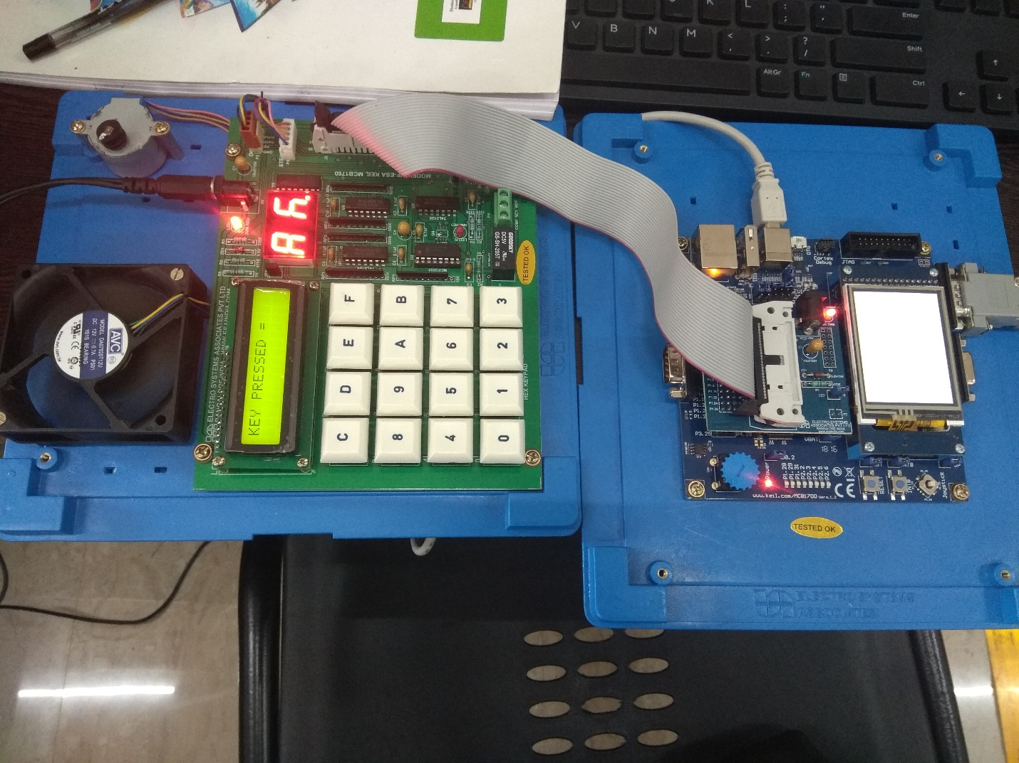

# **Drive link for Video:**

**Regarding Video**

Currently the Password is 5 so when the user enters five the door will open which is indicated by stepper motor rotating clock-wise and all the LED’s will be on and when the user again enters five while the door is already open it closes indicated by stepper-motor rotating anti-clockwise and all the LED’s will be off and if the wrong password is entered three times wrong consecutively buzzer starts buzzing.

Kindly try to observe these features while watching these videos

<https://drive.google.com/open?id=1l641IlHhAKH2HSrPrOMT1RRJPLLjyHZv>

​<https://drive.google.com/open?id=17glk1JyVZIVNoLX1IIXF8cCnzz89mnAG>